https://www.bostonglobe.com/2026/03/17/metro/nh-rural-health-contracts-approval/
Big investment in N.H. rural health secures key approval
Governor Kelly Ayotte called the approval of four contracts a “very important first step”
By Steven Porter Globe Staff,Updated March 17, 2026, 11:03 a.m.
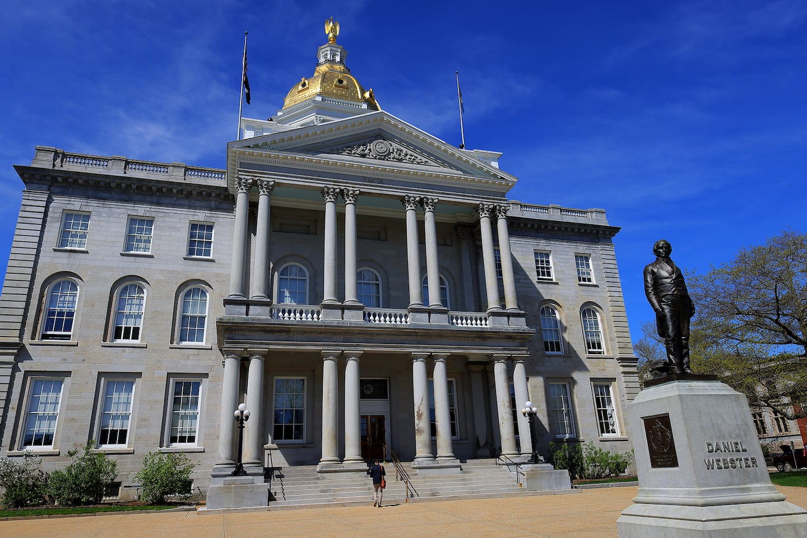Concord, NH. 05/01/25 - The New Hampshire State House in Concord, NH on May 1, 2025. (Lane Turner/Globe Staff) Lane Turner/Globe Staff
CONCORD, N.H. — Four major components of a plan to spend an initial allocation of $204 million in federal funding were approved Monday by the state’s Executive Council as part of a sweeping initiative to support health care access in rural parts of New Hampshire.
The four contracts, worth about $133 million combined, represent the bulk of the state’s initial round of disbursements to establish several “hubs” that will divide and conquer high-priority challenges around health care services, infrastructure, and education.
The councilors, who review all contracts valued at $10,000 or more, had raised questions about oversight and accountability for these funds. But they signed off on the contracts after receiving answers and reassurances that appropriate safeguards are in place, including a cap on indirect administrative costs and a process for subjecting sole-source contracts to additional scrutiny.
FEATURED VIDEO

The state — which established the Governor’s Office of New Opportunities & Rural Transformational Health, or GO-NORTH, to oversee these efforts — aims to qualify for four more years of funding under the federal Rural Health Transformation Program.
Get N.H. Morning Report
A weekday newsletter delivering the N.H. news you need to know right to your inbox.
Enter Email
Sign Up
Congress created the $50 billion program last summer to offset the impacts of federal health care spending cuts under President Trump’s “One Big Beautiful Bill Act,” which some analysts project will reduce federal Medicaid funding for rural health care by $137 billion over the next decade.
Karen Liot Hill, the only Democrat on the Executive Council, said the GO-NORTH initiative includes a number of exciting opportunities for New Hampshire, though she remains worried about the broader impacts from larger reductions in Medicaid funding.
Advertisement

“I am certainly enthusiastic,” Liot Hill said shortly before voting in favor of the contracts. “But I have some tempered enthusiasm knowing what’s ahead.”
John Stephen, one of four Republicans on the council, chimed in to express appreciation for the federal funding, saying it will help New Hampshire maintain a competitive advantage.
Governor Kelly Ayotte, a Republican, said she is proud that New Hampshire received a larger first-year award than any other state in the region. (The other five New England states received between $154 million and $195 million apiece.)
“We have a lot of work to do,” Ayotte said. “But this is a beginning, very important first step in passing these contracts.”
The four approved contracts include:
- $6.7 million to the Community College System of New Hampshire to expand access to health care training, clinical apprenticeships, career and technical education, and more;
- $15.7 million for the University System of New Hampshire to support a variety of programs, including awards for scholars in certain health care fields who commit to practicing in rural New Hampshire for at least five years;
- $43.8 million to the New Hampshire Community Development Finance Authority to support capital improvements, including minor renovations, equipment purchases, and other upgrades for rural health systems and child care facilities; and
- $66.5 million to the Foundation for Healthy Communities to distribute and oversee awards to rural providers and implement efforts to expand access to primary care and other in-demand services.
In addition to those four “hubs,” state leaders are also working on a potential contract with the New Hampshire Community Behavioral Health Association. Those details weren’t presented to the councilors on Monday, but Ayotte said her administration is preparing materials in hopes of asking councilors for their approval on that topic at their next meeting.

This story appeared in Globe NH | Morning Report, a free newsletter focused on New Hampshire, including great coverage from the Boston Globe and links to interesting articles elsewhere. To receive it via email Monday through Friday, sign up here.

