https://newhampshirebulletin.com/2026/03/17/executive-council-approves-first-contracts-for-nh-rural-health-program-after-calls-for-scrutiny/
Executive Council approves first contracts for NH rural health program after calls for scrutiny
By:William Skipworth-March 17, 20261:46 pm
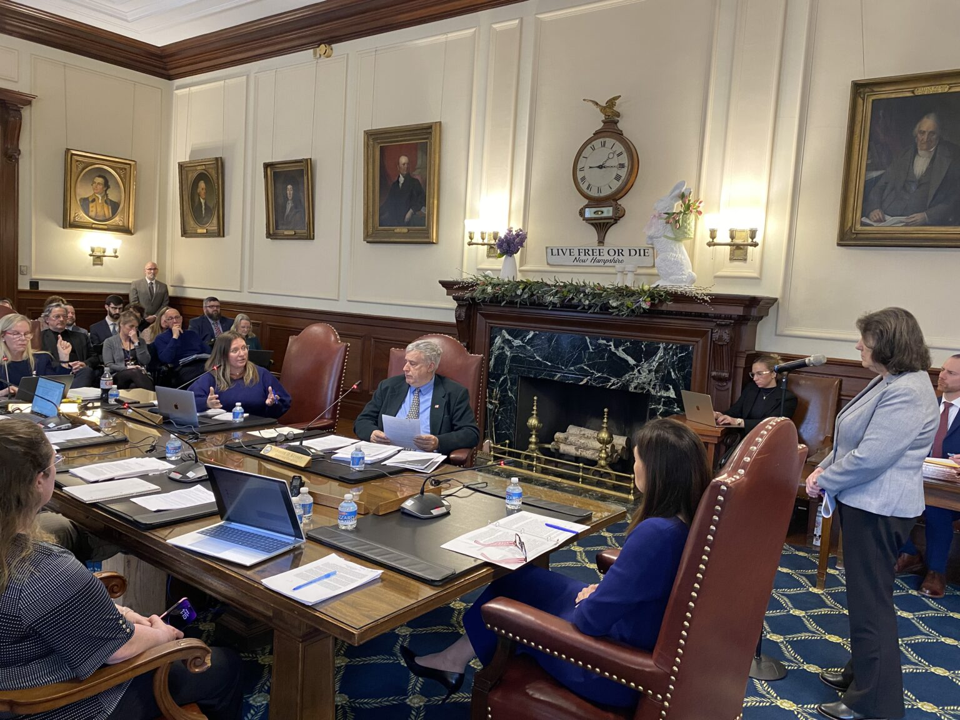
Donnalee Lozeau (right), GO-NORTH director, answers questions from the New Hampshire Executive Council during its March 16 meeting. (Photo by William Skipworth/New Hampshire Bulletin)
After temporarily putting the brakes on the contracts to allow for heavier scrutiny, the New Hampshire Executive Council approved roughly $130 million in funding disbursement for its new marquee rural health program.
New Hampshire is set to receive roughly $200 million annually through the end of the decade from the federal government’s Rural Health Transformation Program. The money is intended to make health care more affordable and attainable in rural areas. In late 2025, Gov. Kelly Ayotte launched the GO-NORTH initiative to spend the federal funds and appointed Donnalee Lozeau, formerly CEO of the Community Action Partnership for Hillsborough and Rockingham Counties, to lead the effort.
That includes potential projects aimed at improving transportation options to and from rural hospitals, expanding telehealth options, and helping rural hospitals navigate the process of being reimbursed by insurers. Councilors also asked that strained rural EMS services and uncompensated care challenges be considered for projects; Lozeau said both were on GO-NORTH’s radar or in the works.
Earlier this month, GO-NORTH brought contracts for approval to the state’s Executive Council to kickstart the work. However, the council, wanting more time to review the contracts and information about the project, tabled them. Ayotte promptly called a special council meeting to continue the discussion. At that meeting Monday, the council unanimously approved the contracts after being assured that safeguards and oversight measures were in place.
The contracts allocate funding to four “hubs” — organizations throughout the state that will in turn reallocate the money to rural health efforts. The hubs are the Foundation for Healthy Communities, the New Hampshire Community Development Finance Authority, the University System of New Hampshire, and the Community College System of New Hampshire. The university and community college systems will handle workforce development projects. The Community Development Finance Authority will work on capital improvement projects for health and child care facilities. The Foundation for Health Communities will handle projects related to primary care access, new technologies, and other issues. GO-NORTH is also planning to provide money to a fifth hub — Community Behavioral Healthcare — but will seek council approval at a later meeting.
Among councilors’ top concerns were that the contracts were sole source, meaning they were awarded to one organization without a competitive bidding process. Lozeau told councilors this is because the organizations were pre-approved by the federal government when New Hampshire applied for the funds and the state needs to move quickly to meet federally imposed deadlines. Lozeau promised that when the hubs disburse money to communities throughout the state, they’ll come to the council again for approval.
The councilors and funding recipients also negotiated a 10% cap on administrative costs that can be covered by this funding.
Additionally, the newly reworked contracts include renewal dates in which the funding recipients must come to the Executive Council for reapproval. The next renewal term begins October 2028.
“This is an enormous sum,” Councilor John Stephen — a fiscal hawk who often leads the council in pushes for higher scrutiny of state contracts — said at the meeting. “That absolutely deserves the kind of oversight the council just gave it.”
The money for this project came from provisions in the One Big Beautiful Bill Act, the sweeping omnibus law President Donald Trump and his allies enacted in July. It’s aimed at counteracting the negative effects analysts predict other provisions of the law will have on rural health systems.

