https://www.nhpr.org/nh-news/2026-03-17/executive-council-approves-go-north-federal-funding-rural-healthcare
Executive Council approves recipients of GO-NORTH federal funding
New Hampshire Public Radio | By Olivia Richardson
Published March 17, 2026 at 12:25 PM EDT
- Facebook
- Twitter
- LinkedIn
- Email
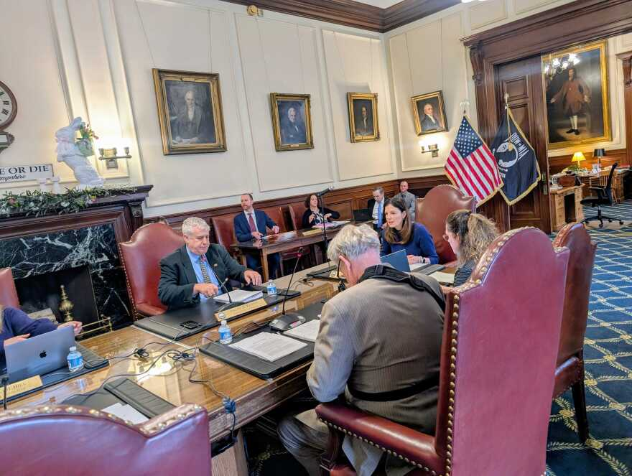
Olivia Richardson
/
NHPR
A special Executive Council meeting to discuss appropriations of GO-NORTH funding took place on March 16, 2026.
Community colleges, universities and health care facilities are set to receive over $204 million dollars in federal funding this year to improve and support rural health in the state, after the Executive Council approved four contracts as part of the Trump administration’s five-year initiative to transform rural health care on Monday.
Contracts were awarded to the state community college system, the University of New Hampshire, the Foundation for Health Communities and the Community Development Finance Authority to improve, among other things, workforce training and health care access.
Earlier this month, the Executive Council voted to table the appropriations over concerns about a lack of transparency in the process.
Donnalee Lozeau, who was appointed by Gov. Kelly Ayotte to run the Governor’s Office of New Opportunities and Rural Transformational Health addressed those concerns in the meeting Monday.
“My goal for GO-NORTH is to make sure that the Executive Council sees the information sooner than it's due. So all the quarterly reports will arrive to you ahead of time,” Lozeau said.
Council members also raised concerns about whether the contracts would address needs for Coos County, given the county’s recent designation as a distressed place-based economy.
Lozeau said GO-NORTH would look for other funding to make sure Coos County doesn’t have to turn down funds in case the county doesn’t have additional funding to support projects they need.
“We're all working together so that we can get the maximum amount of money each year,” Ayotte said at the meeting. “We want to improve healthcare outcomes in this state, especially in our rural areas.”
The state’s plan includes sending money to the community college and university system to improve access to training.
One contract is for the University of New Hampshire, which was awarded over $15 million for the first budget period.
Kirsten Corazzini, the dean of UNH’s College of Health and Human Services, said their funding will be used to create learning hubs in key places, including at the UNH Cooperative Extension in Berlin and White Mountains Community College.
She said they will also create mobile clinics that allow students to run simulations of Emergency Medical Services providers or labor and delivery situations training.
“We want to bring that cutting edge clinical learning right there into the communities,” Corazzini said.
According to a press release from Ayotte, the contract for the Foundation for Health Communities will be used to help rural providers innovate and expand access to primary care and prevention, and improve workforce recruitment and retention.
The contract for the Community Development Finance Authority will support infrastructure improvements and financial stability for rural health care facilities.

